3D printing with 3D Systems Cube 3D Printer

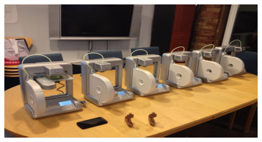
Content developed by: Erica Tiberia and Andy Forest of MakerKids
Contact info: info@makerkids.ca Twitter: @maker_kids

Workshop

Description of workshop:
In this workshop, kids will be given an introduction to 3D printing technology using the Cube 3D printer by 3D systems. This hands-on and interactive exercise has 4 levels of engagement, from beginner to more advanced. Upon completion of this series of activities, participants will be familiar with downloading 3D designs, creating their own designs using 3 different programs, converting their 3D design files to a format that the Cube 3D printer can recognize and print, and uploading and printing their designs using the Cube 3D printer.

Why is this topic important to youth digital literacy:
3D objects made on the computer are brought to life using different methods of digital design, and 3D printing. This gives kids an opportunity to create and contribute to the digital world, and gain a better understanding of a new technology. This also provides foundational experience with 3D design which can be built on using more advanced design programs.

Technology requirements list
Cube 3D printer from 3D Systems
plastic filament (PLA or ABS)
USB stick
Cube software (The Cube ships with easy to use software that preps your files for printing. Available for Mac or Windows.)
CubeStick glue
123D creature (free ipad application)
minecraft downloaded, minecraft login, access to the printcraft multiplayer server
computer/laptop/ipad (one per participant is best, but one per group of 2-4 will also work)

Step-by-step instructions for the facilitator(s)

Basics - Intro to 3D printing and design

Intro to the Cube 3D printer

Intro to Cubify software

Workshop Level 1: Download 3D objects using Thingiverse.com

Workshop Level 2: Design with 123D Creature iPad Application

Workshop Level 3: Minecraft with Printcraft.org

Workshop Level 4: Design with Tinkercad.com

Basics

What is a 3d printable model?

3D designs or models are 3D printable when they can be sent to and read directly by a 3D printer. The industry standard file format which most 3D design software can export to is STL. A .STL file is a 3-dimensional solid computer-aided design (CAD) file that defines the shape to be printed.

3D printable designs must be watertight, meaning that the design has only closed solids, and no open surfaces. All planes must have an internal and external thickness. When you use a Cube 3D printer, the software it comes with will automatically Heal your file for these qualities,

How does 3D printing work?

A 3D printer melts plastic filament (usually ABS or PLA) inside a heated print jet. The print jet deposits this melted filament in thin strings, drawing out the design. The 3D design is broken up into layers, and each layer is printed sequentially, stacking one on top of the other. Each layer makes up an individual XY plane in the design, and the platform slowly lowers after each layer is printed, so that the next layer can print on top of it.
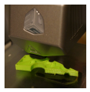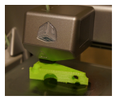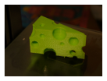

The amount of time a design will take to print is dependent on the size and complexity of the model, and if the object is hollow or solid. It is important to keep this in mind when setting up your programming, depending on how many 3D printers you have access to and how much time you have allotted for your workshop.

The orientation of your design on the print pad is also important. Open spaces and extensions (such as arms or branches) that are away from the centre of the design will need to be supported (plastic doesn't like to be deposited into thin air). Luckily, the Cube 3D printer software can add structural supports to a design that can be removed after printing. The software can also add a raft to your design, which is a removable base layer that typically helps to remove your print from the Cube's print pad once printing is complete.

Intro to the Cube 3D printer

The Cube 3D printer by 3D systems was voted MAKE magazine’s “easiest to use” and “most reliable”. It is very easy to set up, and essentially just plugs in and starts. It is particularly great for an educational platform in a public space used by children and adults, as it has a very intuitive user interface, and is extremely safe (the printing platform doesn't heat up at all! Some models of 3D printers have platforms that heat to over 200 degrees Celsius).

A good introduction to how to use your Cube 3D printer can be found here:

Tips for getting started, such as unboxing, setting up and activating your Cube, and some solutions to Cube 3D printer problems, such as filament flow fail, can be found here, in helpful video form:
http://cubify.com/how_it_works/cube.aspx

An online version of the user guide is located here: http://cubify.s3.amazonaws.com/public/cube/cube_user_guide.pdf

Intro to the Cubify software

The Cubify software comes with the printer (it can also be found for free download here http://cubify.com/cube/). The program slices a 3D design into layers that the Cube can understand and print by converting it to a .cube file.

Make sure the software is installed on all computers prior to your workshop, because it is absolutely required to print anything regardless of the design method you choose.

The Cubify software allows for the manipulation of your design prior to sending it to the Cube for printing. It simulates the Cube's Print Pad, so you can orient, scale, re-size and rotate the 3D print to get the best result when printing.

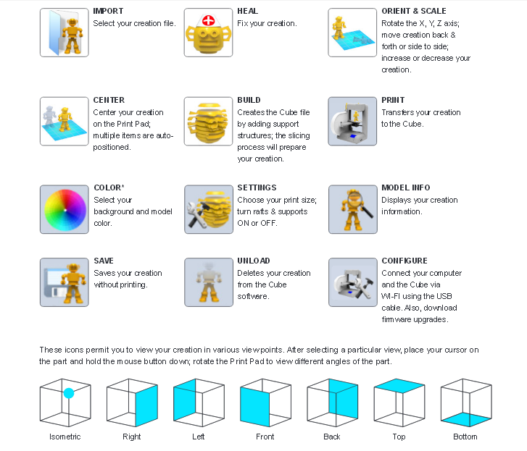

Step 1 – Upload your design, saved in .STL format – click the IMPORT button, select the file name (.STL). Once the upload is complete, your design will appear on the print pad. If the design does not appear, a different design may have already attempted to load. Clicking the UNLOAD button should fix this problem.

Step 2 – Though it may not be necessary, click the HEAL button to fix any problems in your 3D design to prepare it for printing.

Step 3 – Click ORIENT AND SCALE to rotate the X, Y or Z axis, move your design around on the print pad, and often most importantly, increase or decrease the size of your creation (which will greatly effect printing time).

Step 4- Click the CENTER button to center the design on the print pad.

Step 5 – Click the SETTINGS button to choose your print material, whether your design will be printed hollow or solid (which can have a big impact on printing time), and select to print removable structural supports or a removable raft base.

Step 6 – Click the BUILD button to save your design as a .CUBE file. This step adds any support structures or rafts to the design file, and slices the design into layers that the Cube 3D printer can understand and print. You can save this file to a folder on your computer and transfer to a USB stick later, or download it directly to a USB stick.

Step 7 – Plug your USB stick into the Cube 3D printer, add a thin and even layer of glue using the Cube glue stick to the print pad, and follow the directions on the touch pad to print your creation.

Step 8 – Watch as your design comes to life!

Step 9 – Once the print is finished, remove the magnetic print pad from the printer, and carefully remove your design from the print pad. If a raft has been printed with your design (recommended), you may be able to easily remove it. Alternatively, the glue is water soluble. You can rinse the print pad with warm water to dissolve the glue, which helps to detach and remove the printed design.

Step 10 – Show off your brand new 3D printed creation!

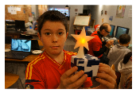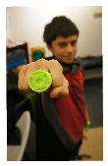

Level 1: Download 3D objects using Thingiverse.com

Thingiverse is an online repository for 3D designs that are submitted by other users. All designs are free, available directly for download and immediate printing. Some designs are customizable. You can also contribute designs of your own!

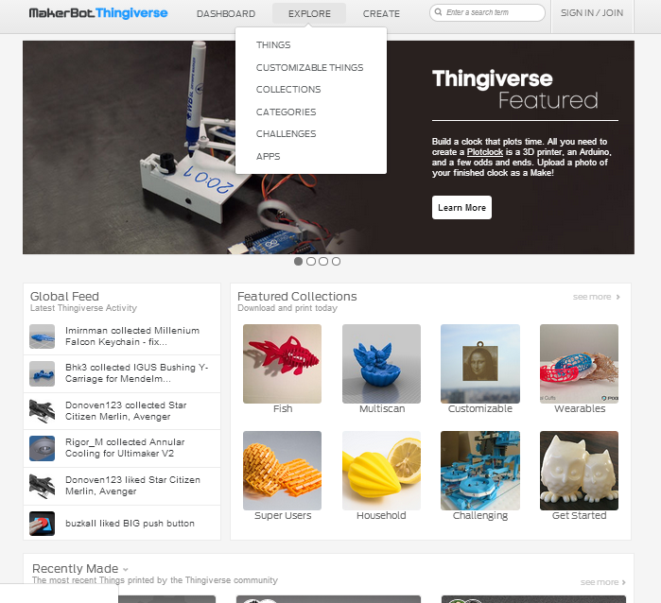

Setup
Go to www.thingiverse.com

Exercise

Step 1: search for specific item by using the search bar on the main page, such as “fish”, or “dinosaur”. You can also click on the “explore” button to explore by category.

Step 2: Once you find a design you like, it is a good idea to make sure the thing has been downloaded, used and “liked” by other users, because there is a better chance it will be a successful print. To start, simpler designs with only one part are encouraged to ensure that there is enough time to print for as many kids as possible.
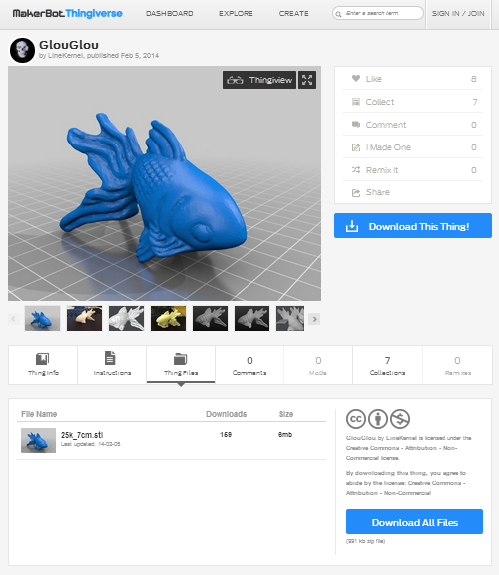

Step 3: Click “download this thing”. Click on the file name ending in .stl.

Step 4: Save the .stl file to a location on your computer that you will remember.

Step 5: Open the file in the cube software, and prepare it for printing as discussed earlier.

Expansion of skills
To expand on the capabilities of Thingiverse, you can try to open a customizable thing and personalize it, or print a more complicated/ multi-part thing. You can also share your designs on the Thingiverse community once you create some designs of your own!

Learning outcomes
Using Thingiverse is a great introduction to how to download .stl files and practice converting them to .cube files for printing. It is also an opportunity to explore, get inspired and learn more about what 3D printing is capable of!

Potential challenges
Sometimes a design will need to be rotated and resized to fit the platform, and more importantly, to fit the time constraints of your workshop. You will have to learn about which designs absolutely require supports and rafts, and which designs should be printed hollow or solid. If there are multiple parts in the final object, it is important to remember that each part must be resized and scaled equally so that they will still fit together!

Level 2: Design with 123D Creature iPad Application

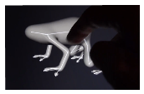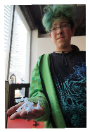

Rationale
The 123D Creature iPad app is a free, easy and fun way to create creatures using an intuitive and awesome touch-screen interface.

Setup
Download the free 123D creature app onto iPads.
For some more information and a video, see: www.123Dapp.com/creature

Exercise

Step 1: At the home screen, you have the option to create new creature, continue a saved project, or download a project created by others. Select create new creature to get started on your first creature!

Step 2: Create a new creature by starting with a simple skeleton type body with legs and arms. The controls at the bottom of the screen allow you to create additional joints and limbs, move them around, change the body shape and thickness, and pose the creature. Create basic skeleton, rough out structure, posture and size of your creature.

Step 3: The next step is to bake the skeleton! This is a silly way of saying that the application is creating the 3D model.

Step 4: You can now choose to sculpt, paint or render. Select sculpt to continue the design process.

Step 5: Sculpt! You can use the sculpting tools to push the surface of the model in or out, you can smooth or sharpen it, and flatten or grab it. There are slider controls to adjust the sculpting tool size and/or strength. The sculpting mode supports mirroring, so if mirroring is on, any change you make to the model is automatically symmetrically mirrored (this is useful for creating things like hands or feet).

Step 6: There is no need to paint the model if the primary use of the model is to 3D print, but it is fun to get more creative with your creature design. You can use paint brush, air brush or image paint functions. Similar to the sculpting module, this painting module also supports mirroring.

Step 7: The Rendering module enables you to create images of the creature you made with varying lighting, background and effects, and you can change the orientation of your creature. There is a sharing function, so you can post your creature on Facebook, print an image, or save it to your ipad's camera roll.

Step 8: Export your creature as a mesh.
Save your creature. Once it’s saved, there is an export as mesh function.
The export as mesh function will allow you to email an .obj file to yourself

Step 9: Convert the OBJ File to STL
Open the file in Meshlab or MakerWare. Export as STL file.

Step 9: Convert to a .CUBE file using Cubify, and print your creature!

Level 3: Minecraft with Printcraft.org

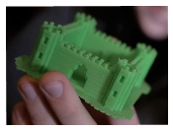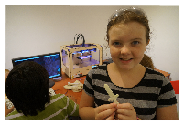

Rationale
Printcraft is a creative multiplayer server in the popular game Minecraft. It is a great 3D design tool that many kids will already be extremely familiar with, making it extremely accessible and fun.

Setup
Access to a Minecraft account and the internet.

You can find more information here:
http://www.printcraft.org/getstarted

Exercise

Step 1: Log in to Minecraft, and click play. You will need to set the Minecraft version to a version supported by the printcraft servers. Usually this is the latest version. If the latest doesn't work, go back to the previous version.

Step 2: Add the Printcraft server! Click the multiplayer button, then select add server. You will be prompted for a name (name this server Printcraft) and add the address: us1.printcraft.org
There is also one in europe, eu1.printcraft.org. Then click done!

Step 3: Printcraft will now be included in your server list. Join the Printcraft server.

Step 4: Find an empty build area. They are marked with the large glowstone squares on the ground. Some build areas are claimed by others, so try to place a stone or sand block to make sure you can build there.
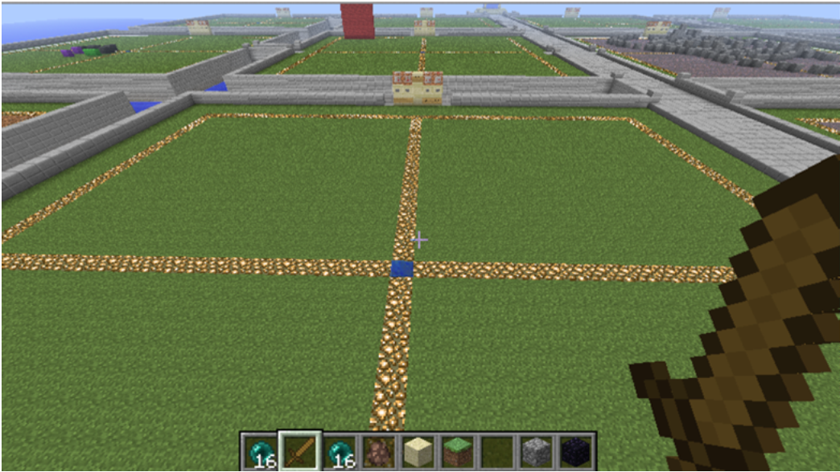

Step 5: Build with sand or clay. Use slabs and stairs to get smaller than 1 block resolution. Keep in mind that the final print will not print with colours, or textures.
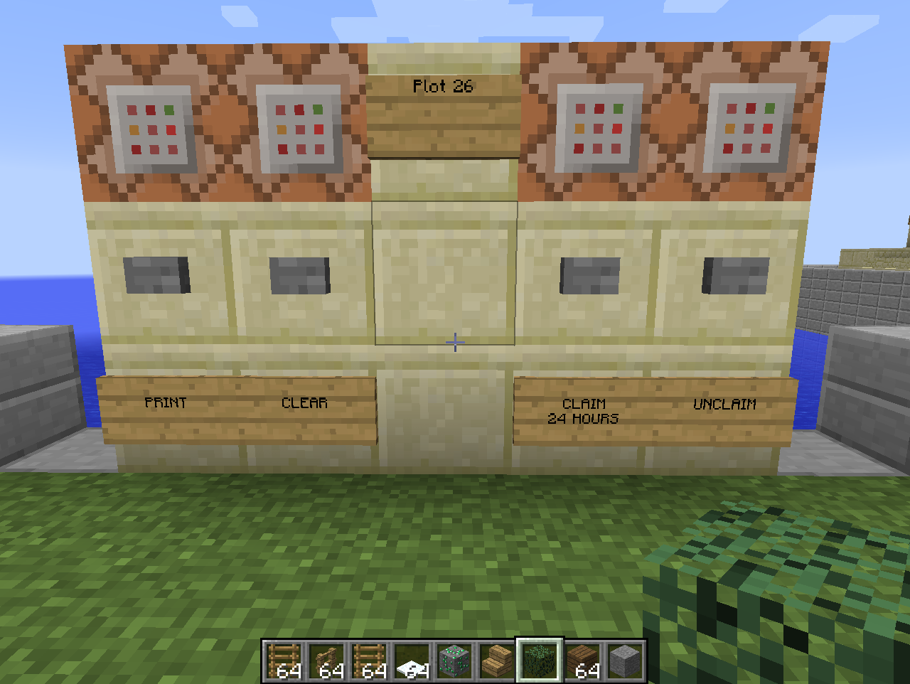
Step 6: Optional - Claim this build area for 24 hours by clicking the CLAIM button. Usually you won't do this, as it prevents others from helping you or using the space when you're finished. If there are a lot of people online, you can use this to protect your work.

Step 7: When done, press the PRINT button.

Step 8: Click on the web link to download the STL file (you have to press “t” to go into chat mode and click the link) This will give you the file that you can download and open in Cubify to print!

Level 4: Design with Tinkercad.com

Rationale
Tinkercad is an easy-to-use browser-based tool for creating digital designs that are ready to be 3D printed. The program guides you through the design process using multiple tutorials and “quests”. Through this process, the user learns basic design tools and progresses to understand more complex modeling techniques. A kid can choose to follow a tutorial to create something and develop new skills, use those new skills to create something from scratch, or customize things other people have built
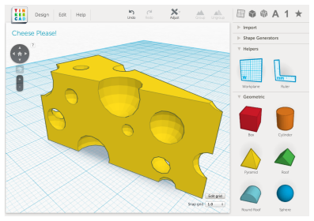

Setup
Go to www.tinkercad.com
Show tinkercad introduction video: https://tinkercad.com/video

Exercise
Have students work through tutorials, which are step-by-step processes to create something that can be modified and printed, which teaches new design skills in the process.

Teaching Tinkercad

Step 1: Watch the TinkerCad tutorial video:
https://www.youtube.com/watch?v=MwjWT-EvKSU

In 2 minutes and 44 seconds, this video shows all the important features of Tinkercad! After watching this, you are almost ready to start designing your own 3D objects.

One very powerful feature of Tinkercad that flashes by rather quickly in the video is the concept of using objects as "Holes". When it gets to this point in the video, pause it so you can elaborate on this. You can set any object as a "Hole", which uses this object to carve away, or subtract from other objects.

Step 2: Guided Instruction

After the video, there are some important things to teach that were not covered adequately. You can quickly show the kids these things before setting them loose.
1. Importance of viewing angles
Emphasize that the angle that you are viewing an object at affects how you can manipulate it. For example, when looking at something at an angle, it is hard to tell where it is positioned. When trying to place one object on top of another, this is a common mistake:

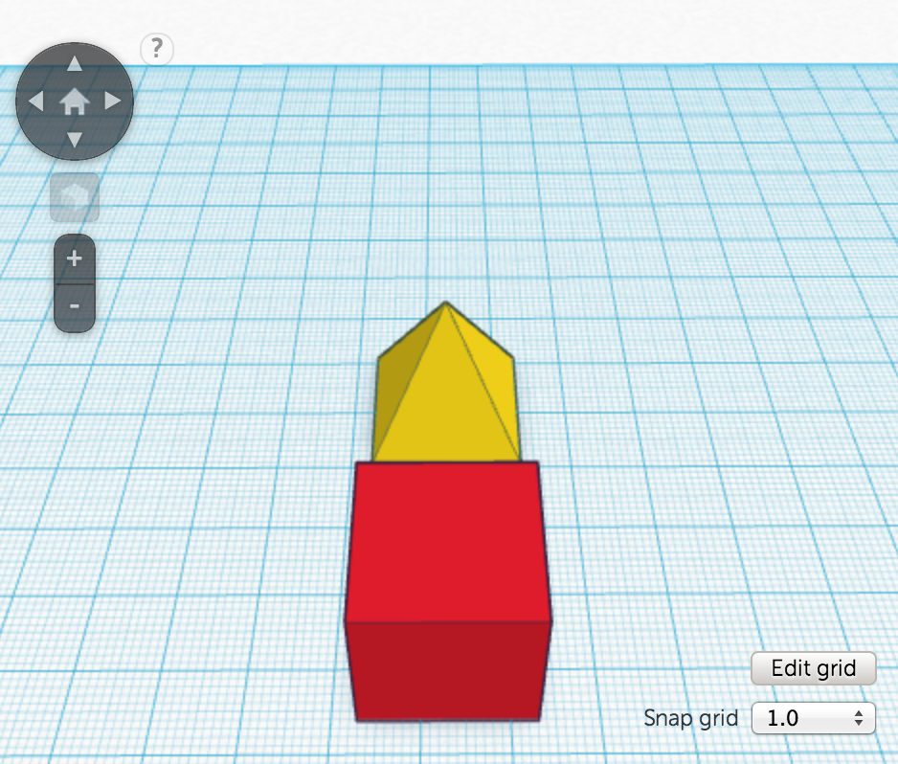
If you continuously change the angle you are looking at the object from, you get a better sense of where things actually are:
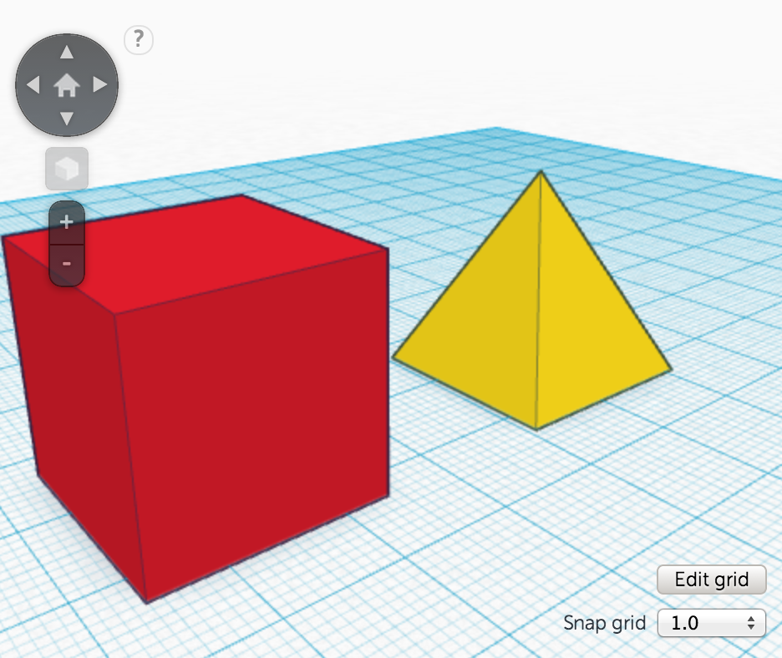

The best way to do it is to look straight down if you are moving an object from side to side. This lets you easily line up the object with other objects in your workspace.

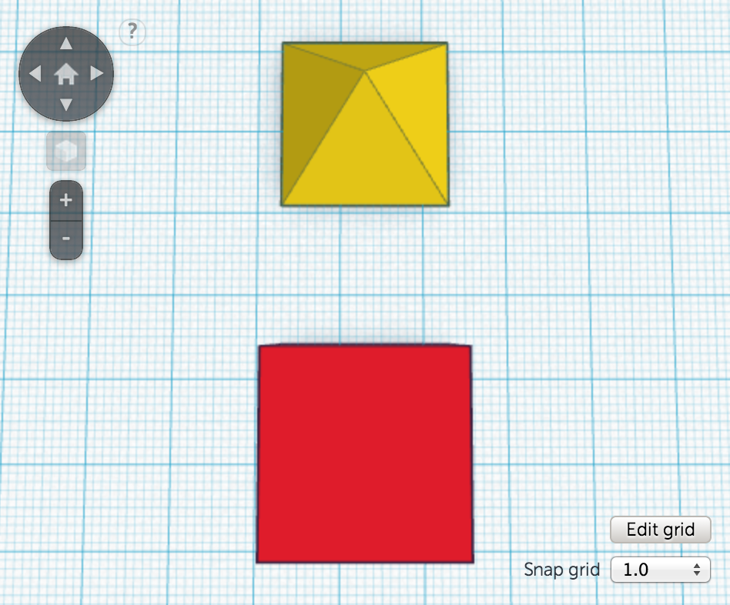

If you need to move objects up and down, change your view to view them straight from the side:
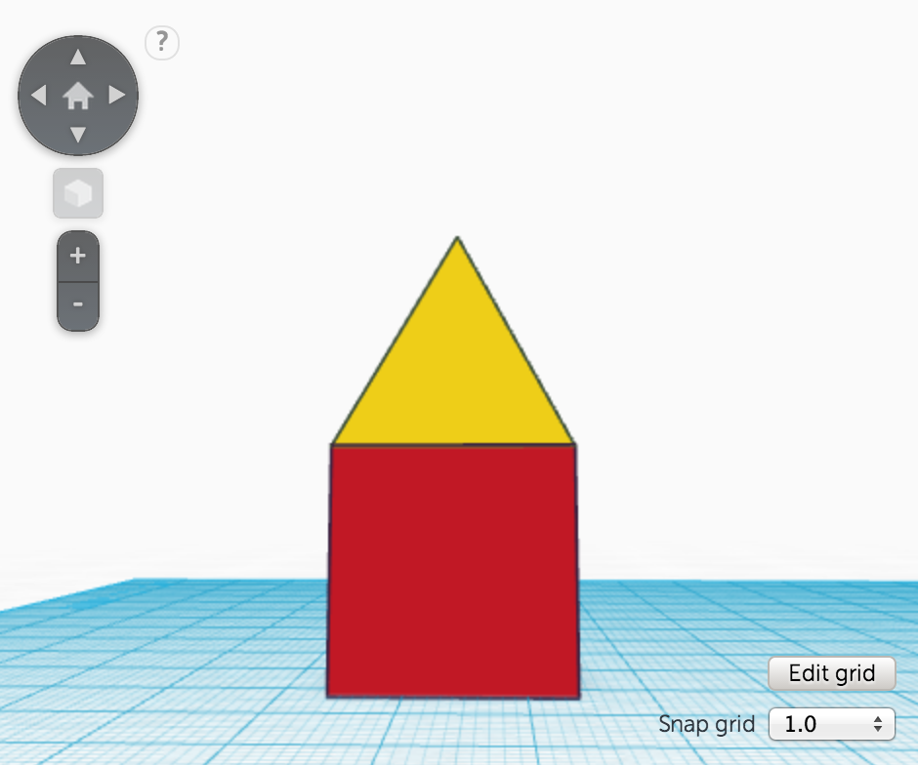

2. Object Generator - Text
Adding text to an object is a quick and easy way to customize it for yourself. There are letter objects that you can drag in one by one, but this is laborious. Fortunately there is a better way, the Text Shape Generator. This allows you to enter in full words, choose a font, and add the 3D text to your creation.

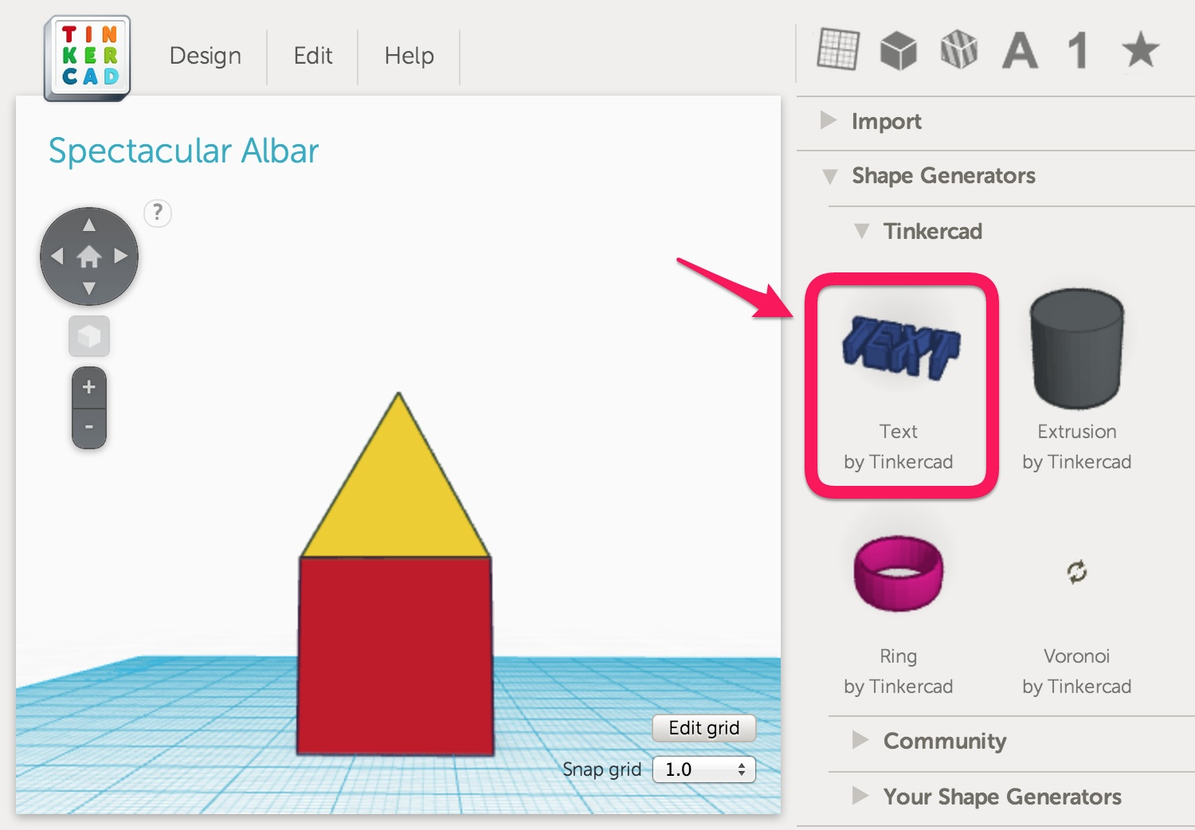
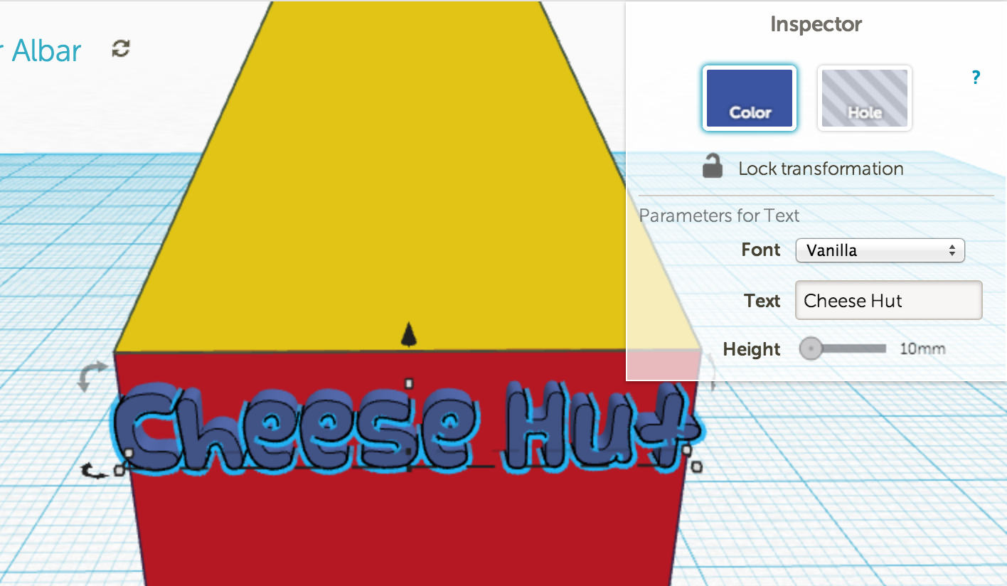

3. Importing STL objects

You can easily import objects from other sources, such as Thingiverse.com. Starting with an existing object quickly gets you partway to your final creation.

Simply download any STL file and use the Import function on the left hand panel to import it in to Tinkercad. Here's an example of a pony character customized to become a unicorn, have a custom crown mark, a ring on her front left hoof, and a pedestal with a name on it:

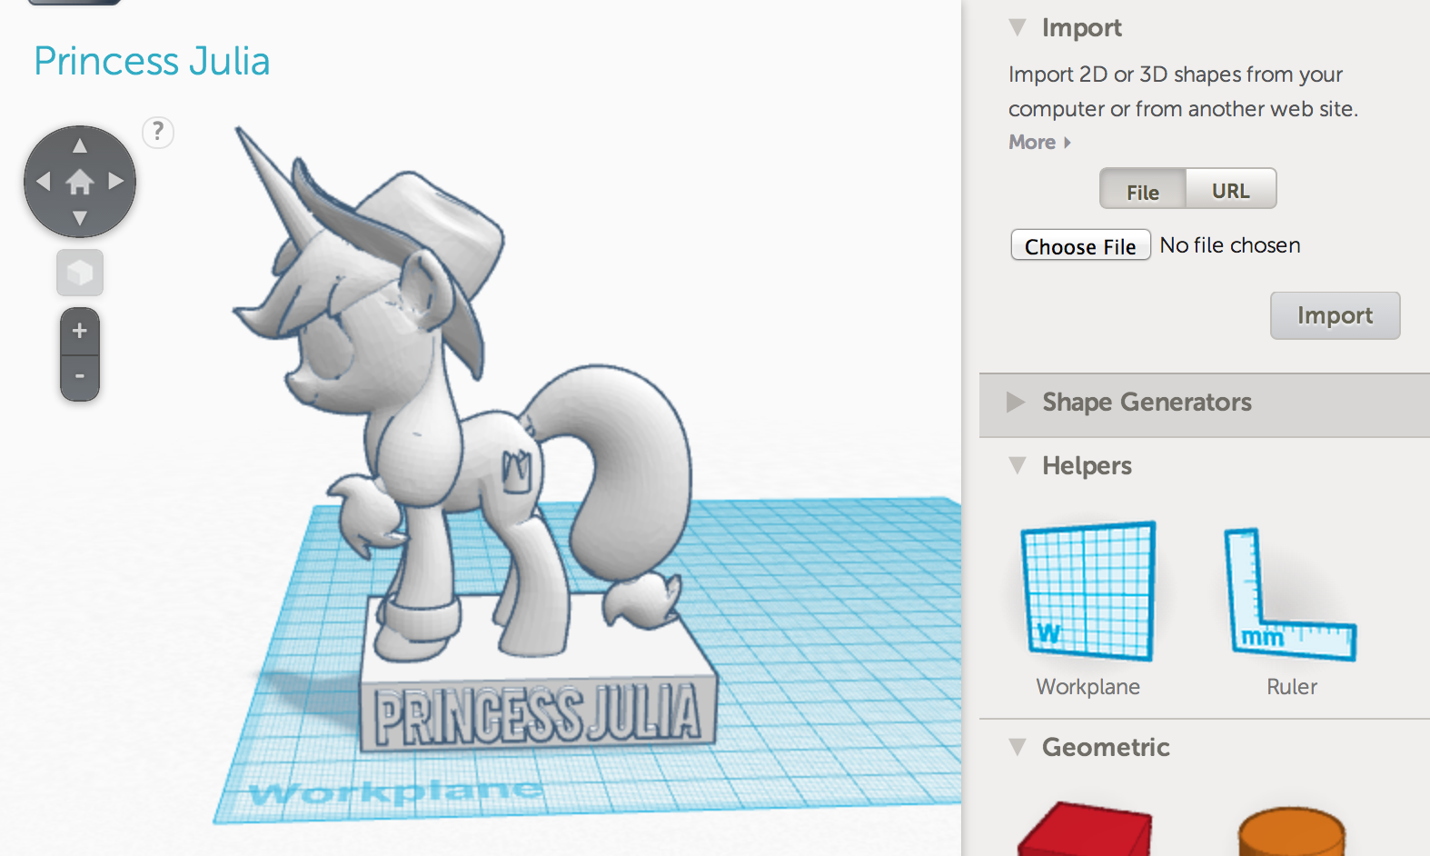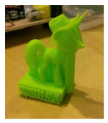

Using Tinkercad

Step 1: Sign up for a free account
Having their own account will allow kids to save their work. They will also be able to track their progress within the tutorials. They must be 13 to create an account.

Step 2: Design an object
Click on the "Create New Design" button.

Step 3: Download for 3D printing
Click on the Design menu, and click on "Save design for 3D printing". Select the button to save as a .STL file. This file can then be opened in Cubify to save it as a .cube file, just like before!

Expansion of Skills
Play the step-by-step lessons to build things that help master further Tinkercad design skills. The lessons are well thought out and teach some important concepts that will help kids design more complex objects.

After completing the basic tutorials, you can direct kids to https://tinkercad.com/quests/ to learn more advanced skills. They can then start from scratch to apply all of these skills and make amazing designs of their own.

Learning Outcomes
Tinkercad is a more complicated 3D design program which allows for more complex designs. This provides a basis for expansion into even more complex 3D design programs, such as other Autodesk products.

*A potential overall challenge for running a 3D workshop
Constraints regarding time, space, and number of 3D printers is a reality that may be a bit tricky to overcome. Kids may not have time to print everything they design. To help with this issue, try scheduling a print queue which includes information about how long the predicted print time is for each design. A simple whiteboard, or even a google calendar may be useful. You can also print designs during non-workshop times, and label the finished prints for pickup at a later date.

Whats next?

Encourage kids to practice their design skills. Provide them with challenges of types of things to design.

