Living L.O.C.A.L. Business Plan

Executive summary

Living L.O.C.A.L. (Local Options for Clemson Area Living) is a business started in October 2011 by Megan Milam, Alanna Slack, Jessica Lau, Lauren DeZervos, and Preston Berkeley. The mission of Living L.O.C.A.L is to promote businesses in the Clemson area that offer local and sustainable products.

The initial focus of Living L.O.C.A.L.’s efforts is to promote awareness of local and sustainable foods amongst Clemson University students by implementing a discount program. Students, faculty, and community members will pay a fee and have the option of choosing between a semester-long and annual membership. The Living L.O.C.A.L. membership card will allow members to receive discounts on local food, goods, and other services at participating farms, restaurants, and businesses.

Living L.O.C.A.L. is a self-sustaining business that will benefit both Clemson University students and the businesses in the Clemson area. Members will have access to local, sustainable options for food and other products; the businesses that participate in the discount program will see an increased customer base and revenue. Membership fees will continue to fund the Living L.O.C.A.L. program and allow for its expansion within the community and to other college campuses. The feasibility of this programs lies in its ease to be transferred to other college campuses. It has little start-up costs, and any community with restaurants and businesses has the resources necessary for Living L.O.C.A.L.

Table of Contents
- Description of business
- Operating procedures
  - Determined eligibility of participating businesses
  - Structure for Living L.O.C.A.L. business operations
- Budget
  - Five-year budget analysis for Living L.O.C.A.L.
  - Use of potential start-up funds
- Marketing
- Competition
- Personnel
I. Description of business
The Living L.O.C.A.L. budget covers printing membership cards, printing and mailing letters and contracts to businesses, buying t-shirts for members, and funding for sustainability projects on campus. Furthermore, funds will be set aside to help other campuses around the country start their own Living L.O.C.A.L. program.

The program website (currently located at livinglocal.weebly.com) will serve as the central base of Living L.O.C.A.L. It is a major advertising tool, and will have separate pages for each campus chapter. The main website will have general information about the program, as well as a password-protected start-up information packet (including letters and contracts to be sent to companies as well as the business plan) to be utilized by universities interested in starting a chapter. Each university’s individual page will include the available discounts at participating businesses, contacts of the program coordinators, and information on purchasing membership cards.

Modeled after the successful IPTAY discount program at Clemson University, Living L.O.C.A.L. will send out a letter and a contract to each potential business. The contract will require the business to declare which products will be discounted for the year. Living L.O.C.A.L. will have requirements each product must meet in order to receive sustainable status. Our program offers consultation to businesses unsure of how to pursue sustainability.

Potential target partner businesses in the Clemson area:
- Farms, co-ops, and other food distributors
- Student Organic Farm
- Farm Fresh Market
- Garrison Denver Down Corn Maze
- Kathy’s Produce
- Amazing Savings
- Upstate Food Co-op
- Winnie Mae’s
- Restaurants
- Blueberry Frog
- Moe Joe’s Coffee
- Brioso
- Happy Berry
- Hudson Bagel Company
- Woodstone Pita
- Pita Pit
- Super Taco
- Main Street Deli and Coffee House
II. Operating procedures summary

In the fledgling years of Living L.O.C.A.L., volunteers will approach potential businesses to explain the concept of the L.O.C.A.L. card. The business managers will be given information on how to determine if they qualify for the program. Eligible businesses will sign contracts stating the discounts they will offer for the year, and a membership fee of $10 per semester will allow members access to all business discounts and a complimentary t-shirt. After the initial years of operation and our business produces a profit, we reserve the right to designate a percentage of the profits towards other sustainable initiatives on campus.

A. Determination of participating business eligibility

The eligibility of businesses to join Living L.O.C.A.L. will be determined with a point system. Different specifications of sustainability within restaurant operation will be weighted by relevance to the Living L.O.C.A.L mission, the operational and economic feasibility of the specifications, and the magnitude of reduced energy use made by the sustainable changes. The restaurant managers will especially be notified of the undemanding operational changes that will result in huge cost savings, as a result of the energy savings.

Potential businesses will have access to a password-protected survey form on the website. The form will be designed with a user-friendly interface and consist of questions concerning the source of food, management of waste, and efficiency of energy use. Our group formulated questions that all business owners can answer with ease. The completed form produces a sustainability score for the businesses, which determines if they qualify or not. Each business’s performance in the three areas will be displayed, and managers will be able to access information on improving their business’s weaknesses, as well as compare themselves to other local restaurants. By providing business owners with sustainability information when they register their businesses for Living L.O.C.A.L., we will further promote the social, economical, and environmental benefits of sustainable practices.

Sample questions from the survey:
Do you receive all of your shipments from a single source?
What percentage of your food comes from within 100 miles? 500 miles?
How many times do you receive shipments of non-local products per month?
What percentage of disposables do you recycle?
Do you donate your used cooking oils to Clemson’s biofuel lab?
What percentage of your appliances are Energy Star certified?

The excel spreadsheet that calculates the eligibility for businesses is attached.

B. Structure for Living L.O.C.A.L. business operations

An email account (clemsonlivinglocal@gmail.com) provides most of the necessary communication between customers and business partners and Living L.O.C.A.L.

The Living L.O.C.A.L. website (livinglocal.weebly.com) is the prominent source of information for businesses and customers. A PayPal transaction system will be set up on the website to collect membership fees. Members can access the site to find information on participating businesses and available discounts, as well as membership fees, merchandise, and other ways to get involved in the Living L.O.C.A.L. cause. Businesses can use the site to gauge what their competition offers, their sustainability performance as recorded by the surveys, and information on ways to improve specific areas of operation.

Distribution of membership cards, advertising, and recruitment of new members will largely be supported by manning tables in popular student thoroughfares such as Library Bridge at Clemson University. A volunteer base (possibly managed by a Creative Inquiry course) will provide most of the manpower behind corresponding with participating businesses and working with them to meet sustainability standards. Volunteers will receive compensation for the recruitment of new businesses and new membership. The budget accounts for some monetary compensation, and further compensation will be distributed in the form of discounted membership fees.

III. Budget

- Five-year budget analysis for Living L.O.C.A.L.

We have put together a budget estimate for the first 5 years (10 semesters) of operation for Living L.O.C.A.L. The two tables below detail the exact items that went into these calculations and include conservative estimates for the price of each item.

Estimated cost of operations
Item | Cost ($)
 | First semester | Subsequent semester
Website design | 1000 | N/A
PayPal transaction fee | 2.9% of total transactions + 0.30 per month (4 months per semester)
Card printing | 50 for 250 cards
Paper printing and mailing | 100
T-shirts | 500 for 100 shirts
Compensation for hours worked | Dependent on number of members; see table below

Breakdown of compensation for hours worked in one semester
Item | Description | Compensation | Estimate used in calculations
Website maintenance |  | $8/hour | 5 hours
Advertising | Creation and posting of flyers | $8/hour | 5 hours
Membership solicitation | Membership discount for people who sign others up for the program | $5 discount for every 10 people signed up | Dependent on number of members
Business eligibility determination | Initial contact businesses, helping businesses to complete sustainability evaluation | $10/business | 20 businesses

Using the budget items detailed above, estimates for the cost of operations during each semester is shown in the below table. In order for income from membership fees to equal the expenditures from the very first semester, we will need to have 210 members join our program during the first semester and 101 members for each subsequent semester. However, this is not the most feasible or realistic plan of expansion for our program, and we instead use an adjusted estimate of membership growth shown in the last column of the table below to do a break-even analysis.

Membership numbers for the first 5 years, membership fee: $10
Semester | Estimated cost of operation ($) | Number of members needed to break even | Anticipated number of members
1 | 2097.1 | 210 | 60
2 | 1011.78 | 101 | 80
3 | 1011.78 | 101 | 100
4 | 1011.78 | 101 | 120
5 | 1011.78 | 101 | 140
6 | 1011.78 | 101 | 160
7 | 1011.78 | 101 | 180
8 | 1011.78 | 101 | 200
9 | 1011.78 | 101 | 220
10 | 1011.78 | 101 | 240

A break-even analysis was performed with the estimated numbers for membership growth, with two varying factors. First, we considered semester-long membership fees of $10, $15, and $20. Further, we do not yet have a fully formed plan for how to implement our program, with regards to personnel and monetary compensation for hours worked. We have thus considered running the business with a strictly volunteer base as the source of manpower, as well as with monetary compensation being given to the students working in our business. The results of the analysis are shown in the table below.

Membership fee ($) | Number of semesters to break even
 | Including compensation for hours worked | Excluding compensation for hours worked
10 | 7 | 5
15 | 4 | 2
20 | 2 | 0

Based on this analysis, we have decided that $10 per semester will be an appropriate membership fee. A higher fee might result in reduced participation in the program, and the time required to break-even with a $10 per semester fee is still relatively short. Analysis results are also shown in the two graphs below.
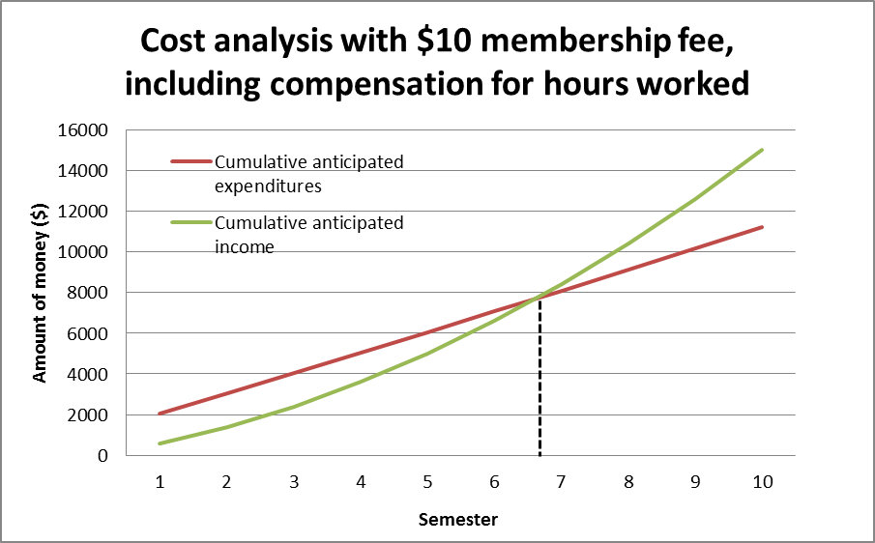

Taking worker hour compensation into account yields a break-even time of just under 7 semesters, or 3.5 years.

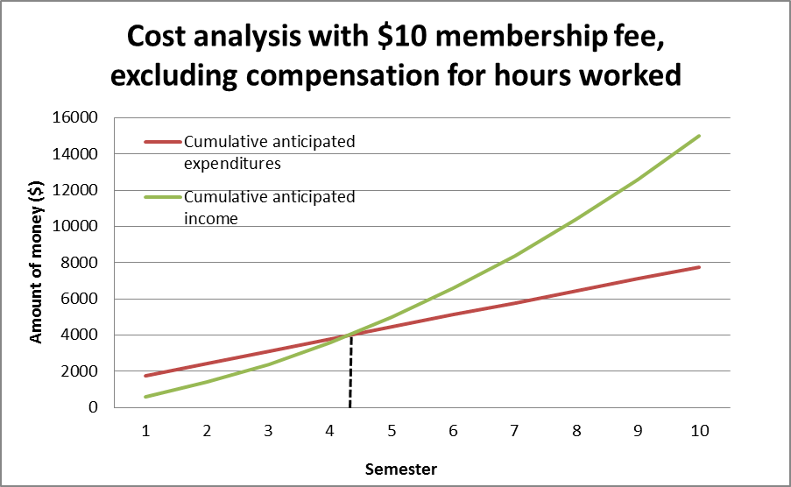

If Living L.O.C.A.L. operates on a strict volunteer base and does not provide monetary compensation for hours worked, it will take just over 4 semesters (2 years) to reach the break-even point.

This break-even analysis highlights the fact that the Living L.O.C.A.L. program is a feasible and financially viable business. The operation costs for the entire business are low, staying at about $1000 for each semester (with the exception of the initial semester, where an investment in developing the website increases expenditures to around $2000). Whether the program chooses to provide monetary compensation for its workers or not, it would take a relatively short amount of time to reach a break-even point. After that point, excess income will contribute to funds to be donated to other sustainability projects.

B. Use of potential start-up funds
A start-up fund of $5000 will go a long way to helping the Living L.O.C.A.L. program meet its goals. As discussed before, a conservative estimate of expenditures during the first semester is around $2000; subsequent semesters require just over $1000 per semester in spending. The start-up fund would cover our operating costs for up to two years, allowing us to put extra income into expanding other parts of the business.

A good portion of the membership fees could go directly into supporting a local sustainability project, as determined by a popular vote by the members. This would raise awareness of sustainability projects and initiatives in the Clemson area; Clemson students, faculty, and residents would have more of an incentive to participate in the Living L.O.C.A.L. program if their fees go directly to funding sustainability projects rather than into supporting the basic operations of the business.

Extra income could also go to improving membership benefits—for example, providing members with a t-shirt during each semester that they participate in the program, as opposed to just for their first semester of participation. Finally, expansion of the Living L.O.C.A.L. program to other college campuses can be supported by the extra funds. The program is a viable business with low operating costs, and can be readily implemented in other areas to spread awareness of sustainable food practices.

IV. Marketing

The Living L.O.C.A.L. discount program will be marketed on a number of different platforms. The Living L.O.C.A.L. website will serve as the major mode of communication and advertising to the general public. Other modes of advertising include flyers, posters, an information booth at Market Day, a listing in the weekly Clemson University events e-mail distributed to the entire student population, and t-shirts (with participating businesses listed on the back) available to program members.

V. Competition

The well-established Clemson Athletics IPTAY discount program will be potential competition to the Living L.O.C.A.L. discount program. The two programs target local businesses in the Clemson area, so business participation overlaps. Furthermore, students may be more attracted to the IPTAY program because it offers discounts for all products, not just the ones that fall under the definition of being local and sustainable. Living L.O.C.A.L. will have to work with its business partners to ensure that local options remain a competitive option; for example, the discounts on more sustainable products would have to be greater than the blanket discount for all goods available at the business.

VI. Personnel

There are five Clemson University undergraduate students currently heading the Living L.O.C.A.L project: Megan Milam, Alanna Slack, Jessica Lau, Lauren DeZervos, and Preston Berkeley. Leidy Klotz and Jennifer Goree are serving as faculty advisors for the project.

